Davidian Platters
House Salad
Romaine and Iceberg Lettuce, Cucumbers, Red Onion, Carrots, Peppers
Serves 10 People: $21.99
Serves 20 People: $39.99

Antipasto Platter
Iceberg & Romaine Lettuce, Tomatoes, Onions, Peppers, Cucumbers, Genoa Salami, Capocollo, Pepperoni, Provolone, Banana Rings.
Serves 10 People: $21.99
Serves 20 People: $39.99

Mediterranean Platter
Hummus, Greek Olives, Grape Leaves, & Feta
Serves 10 People: $33.99
Serves 20 People: $56.99

Finger Sandwiches
Chicken, Egg, Seafood, Tuna, & Ham Salad
Or choose any of our cold Deli Meats
Serves 12 People: $30.99
Serves 24 People: $56.99
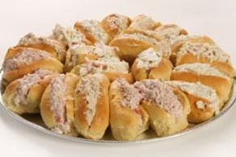

Fruit Platter
(no dip included)
12” (Serves 10-15 People): $33.99
16” (Serves 15-20 People): $41.99
18” (Serves 20-25 People): $47.99
Veggie Platter
12” (Serves 10-15 People)
W/Dip: $27.99 - W/o Dip: $31.99
16” (Serves 15-20 People)
W/Dip: $37.99 - W/o Dip: $41.99
18” (Serves 20-25 People)
W/Dip: $41.99 - W/o Dip: $46.99

Cheese & Pepperoni Platter
Mixture of Cheeses and Pepperoni. (Crackers available for an additional charge)
Small: 3 Cheeses + Pepperoni: $31.99
Medium: 4 Cheeses + Pepperoni: $36.99
Large: 5 Cheeses + Pepperoni: $44.99

Davidian’s Special
Honey Ham, Land O’ Lakes Cheese, Roasted Turkey, Swiss Cheese, Roast Beef
Serves 10-15 People: $47.99
Serves 25-30 People: $77.99

Northborough’s Special
Imported Ham, Hot Capocollo, Honey Maple Turkey, Chicken, Roast Beef, Provolone, Land O’ Lakes Cheese
Serves 10-15 People: $47.99
Serves 25-30 People: $77.99

Fruit Baskets, Gift Baskets, & More
Custom made by Nancy Davidian to include exactly what you want. They can include fresh fruit, gourmet items, baked goods, jams & jellies, nuts, & dried fruits.
Starting at $45.00

You can order directly from our menu for your special event, or we can create a custom menu for your personal taste. Just ask!
Please provide at least 24-hour notice on all orders.
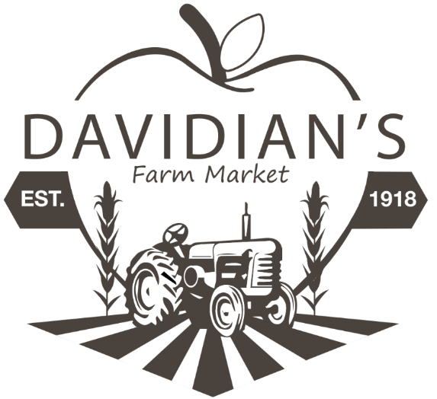

Deli Menu

Dietz & Watson Meats and Cheeses

| Soups | Chili | Salads | Sandwiches |

Enjoy your lunch upstairs in the Farmhouse Loft or relax at our outdoor seating. Call ahead to have your order ready for easy pickup.
Wi-Fi Friendly.

Davidian’s Farm Market
500 Church Street
Northborough, MA 01532
(508) 393-3444, Prompt 2
www.davidiansfarm.com

Before placing your order, please inform your server if a person in your party has a food allergy.

| Soups |
Try our delicious chili made fresh daily. Ask about our soup of the day! Soups available seasonally.
Chowder & Chili
Cup: $5.25 - Pint: $6.75 – Quart: $10.99
Soups
Cup: $4.75 - Pint: $6.45 – Quart: $10.45

| Quick Bites |
Kayem Hot Dog $2.50
Chili Dog: $3.50
Kraut Dog: $3.50

| Davidian Kids |
Peanut Butter & Jelly $4.99
Peanut Butter & Marshmallow Fluff $4.99
Sandwich with meat on sliced bread
(Includes apple and a cookie): $6.99

| Salads |
Red Bliss Potato Salad $5.49/lb
Pasta Salad w/ Italian Dressing $3.99/lb
Pasta Salad w/ Mayonnaise $3.99/lb
More available on rotation, just ask!

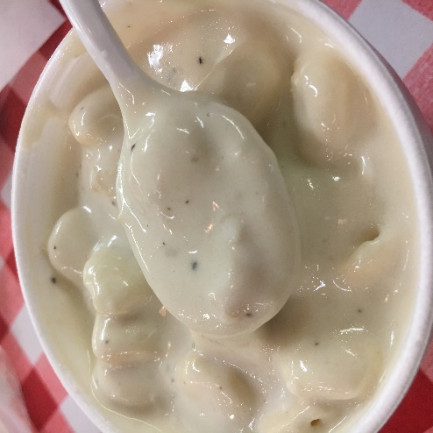

Spreads
Yellow Mustard, Honey Mustard, Spicy Mustard, Mayonnaise, Hoagie Oil, Horseradish Sauce, Russian Dressing, Ranch Dressing
Garnishes
Cucumbers, Lettuce, Tomato, Red Onion, Hot Pepper Relish, Banana Peppers, Green Peppers, Roasted Red Peppers, Pickles, Olives, Spinach

Breads/Wraps
Bulkies and Subs
Wraps: Plain, Wheat, Tomato, Spinach
Bread: White, Wheat, Rye, Pumpernickel
Gluten Free White Bread $1.00 extra

| Specialty Sandwiches |
Sub/Wrap: $9.49 | Bulkie/Bread $8.99

1. Hummus Wrap
Lettuce, Tomato, Cucumber, Roasted Peppers, Baby Spinach, Onion, Our Own House-Made Hummus

2. Pilgrim Wrap
Roast Turkey, Stuffing, Cranberry Sauce

3. B.L.T.
Crispy Bacon, Fresh Shredded Lettuce, Tomato

4. Choice of Salad Sandwich
Chicken, Cranberry Almond Chicken, Tuna, Seafood, or Turkey, Ham, or Egg Salad with Garnishes

5. Lean & Mean Pastrami
Lean Pastrami, Swiss, Spice Mustard

6. Reuben
Corned Beef, Sauerkraut, Russian Dressing, Swiss

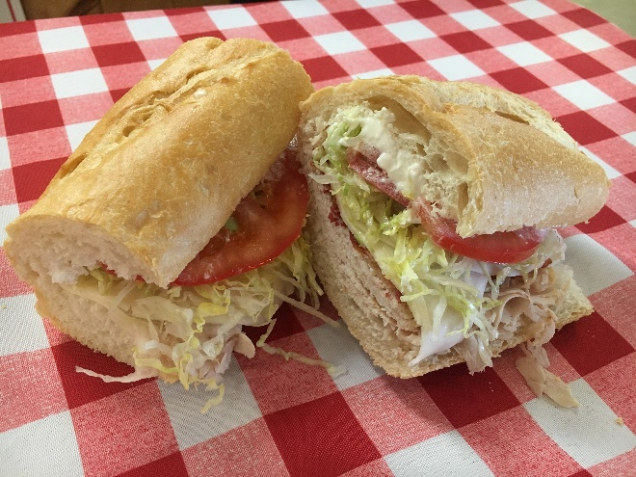

7. Italian Classic Hero
Imported Ham, Genoa Salami, Sweet Capicola, Pepperoni, Provolone, Lettuce, Tomato, Onion, Pickles (Traditionally on a Hoagie Roll)

8. Veggie Wrap
Shredded Lettuce, Tomato, Baby Spinach, Red Onion, Olives, Cucumber, Roasted Red Peppers, Feta

9. Roast Beef
Roast Beef, Cheddar, Lettuce, Tomato, Red Onion

10. The Russian Gobbler
Roasted Turkey, Coleslaw, Russian Dressing (Traditionally on Rye)

11. Chicken Caesar Wrap
Classic Chicken, Shredded Lettuce, Croutons, Baby Spinach, Olives, Parmesan Cheese, Caesar Dressing

12. Turkey Bacon
Turkey, Bacon, Swiss Cheese, Lettuce, Tomato, Red Onion

…or customize your own!

